**Practical 4 Part A: Building a CI/CD Pipeline with Jenkins.**

***Here in part A we are only working on CI .***

1. **Login to your Jenkins localhost:8080/**

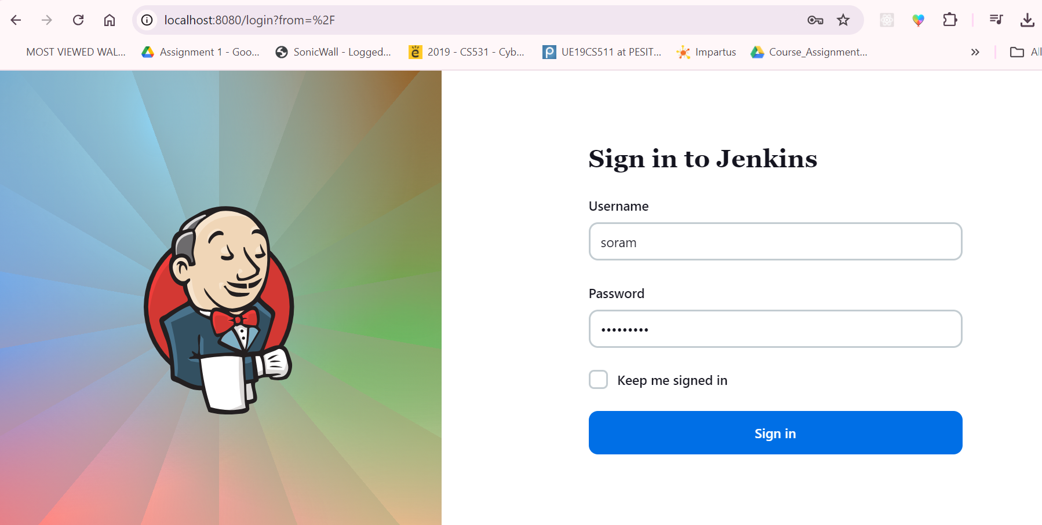

1. **Create a new job.**

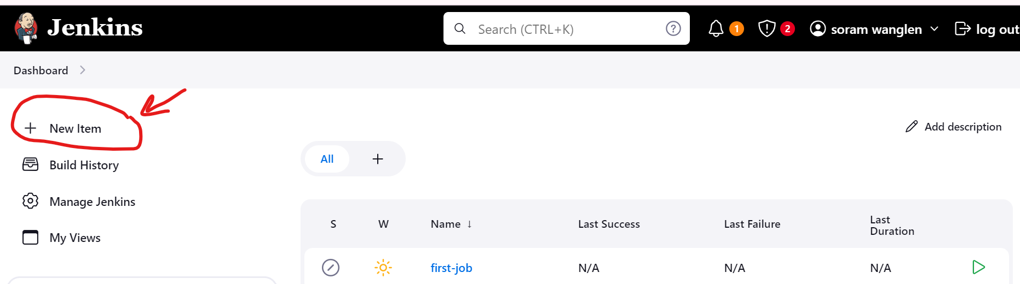

1. **Now configure your job.**

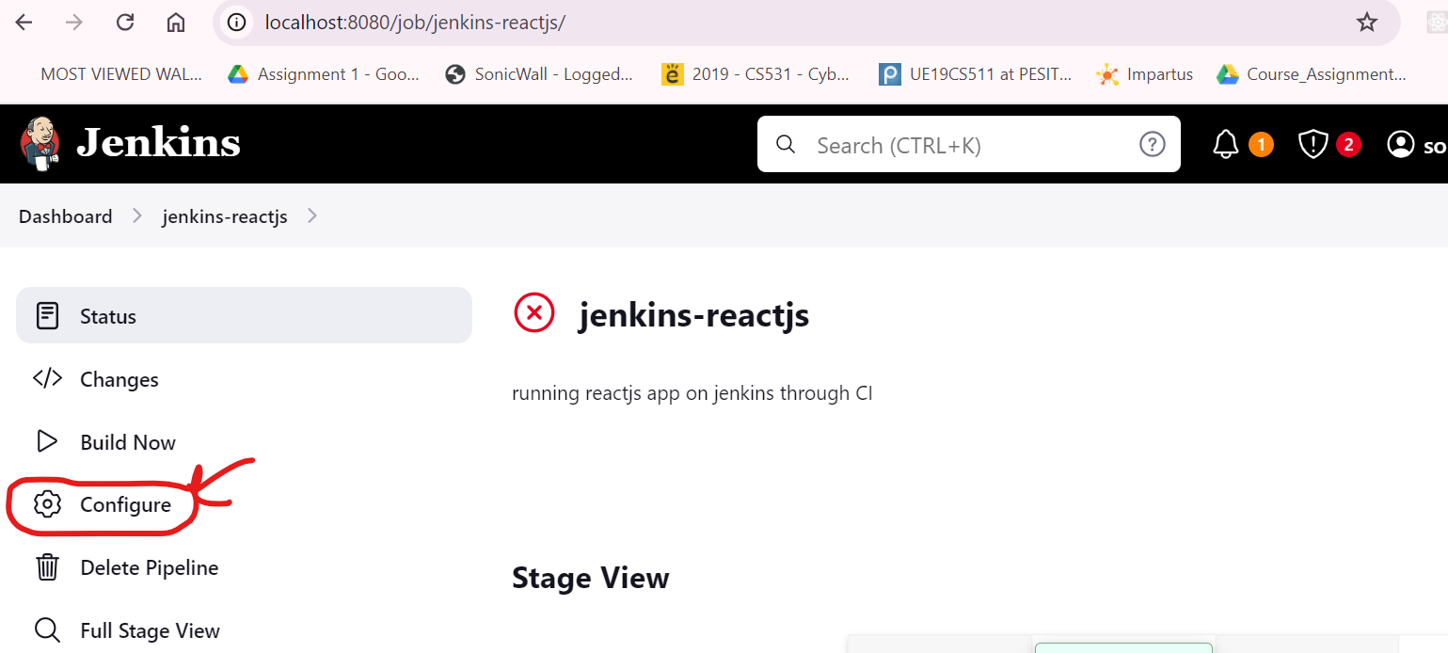

1. **Now provide github repo link and description.**

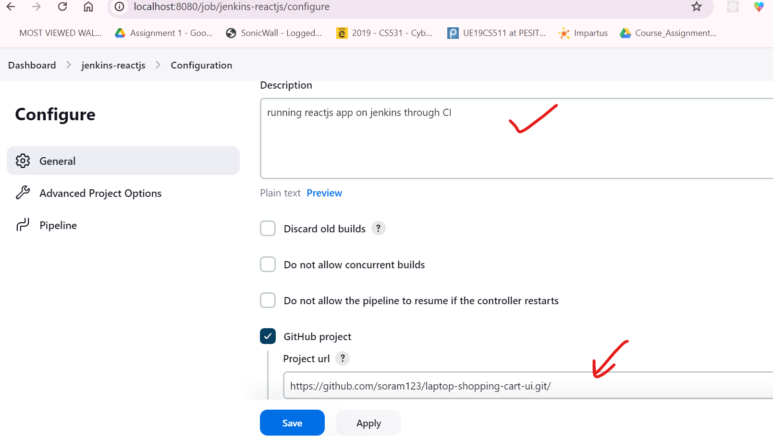

1. **Check the github hook trigger.**

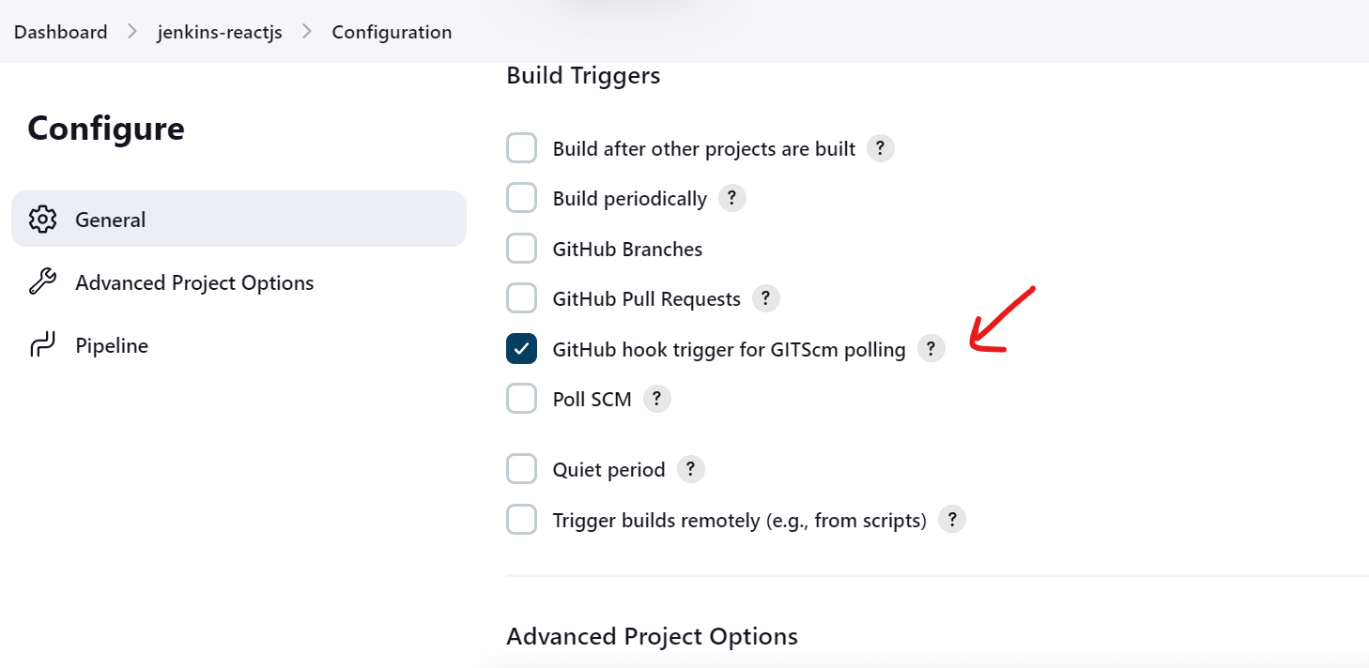

1. **Now write the pipeline script.**

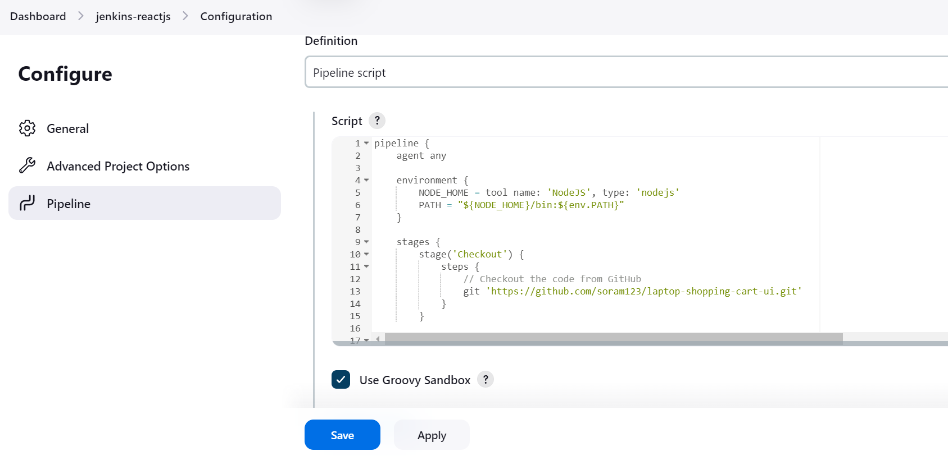

**Here is the script for pipeline:**

pipeline {

agent any

environment {

NODE_HOME = tool name: 'NodeJS', type: 'nodejs'

PATH = "${NODE_HOME}/bin:${env.PATH}"

}

stages {

stage('Checkout') {

steps {

// Checkout the code from GitHub

git 'https://github.com/soram123/expressjs-jenkins-aws.git'

}

}

stage('Check Node Version') {

steps {

bat 'node -v' // This should print the Node.js version

bat 'npm -v' // This should print the npm version

}

}

stage('Install Dependencies') {

steps {

// Install npm dependencies

bat 'npm install'

}

}

stage('Run nodejs app') {

steps {

bat 'npm start '

}

}

}

}

**Note : if you are using ubuntu instead of windows OS change “bat” with “sh”**

1. **Now click on the build .**

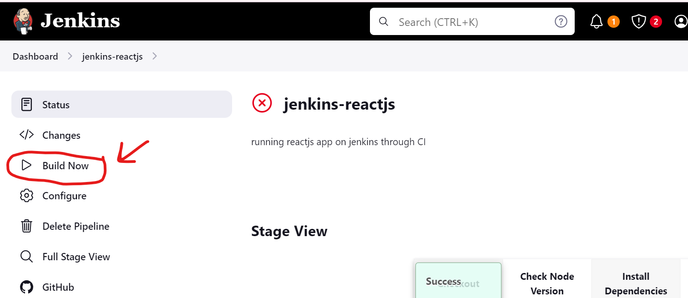

1. **Now click on job and goto console output.**

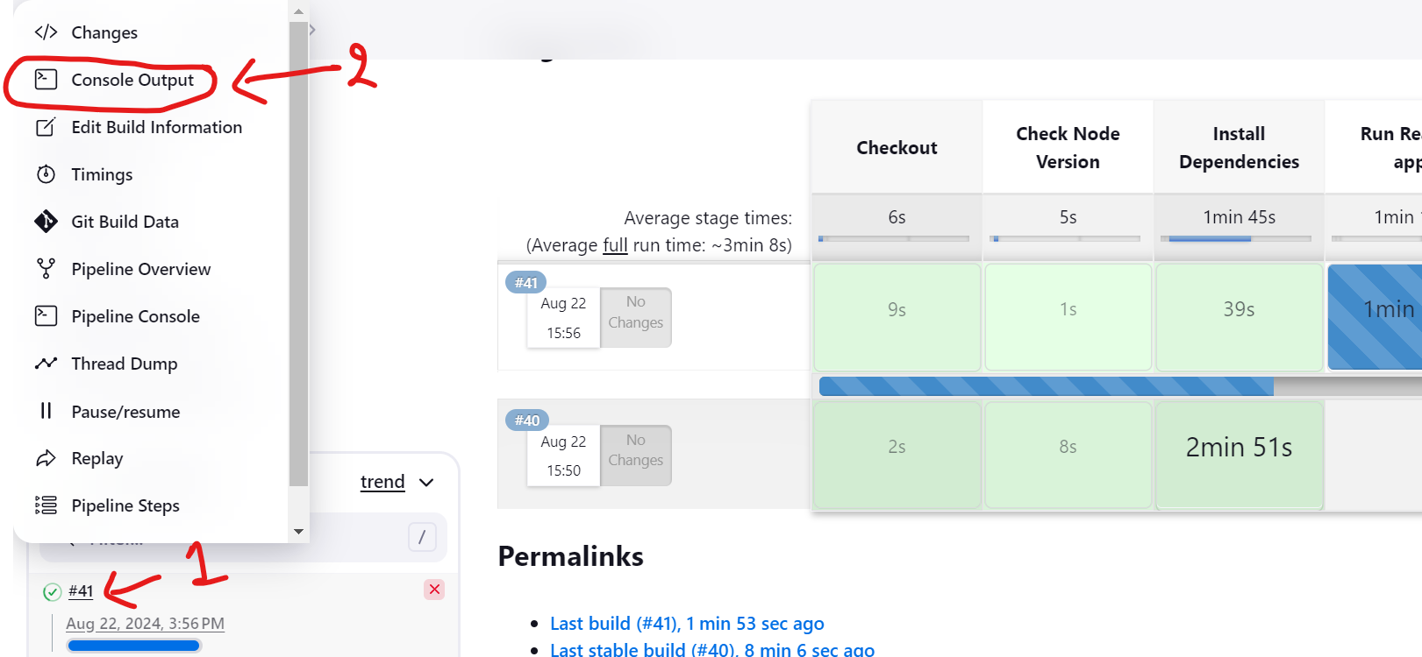

1. **Now you should see your app running without any issue.**

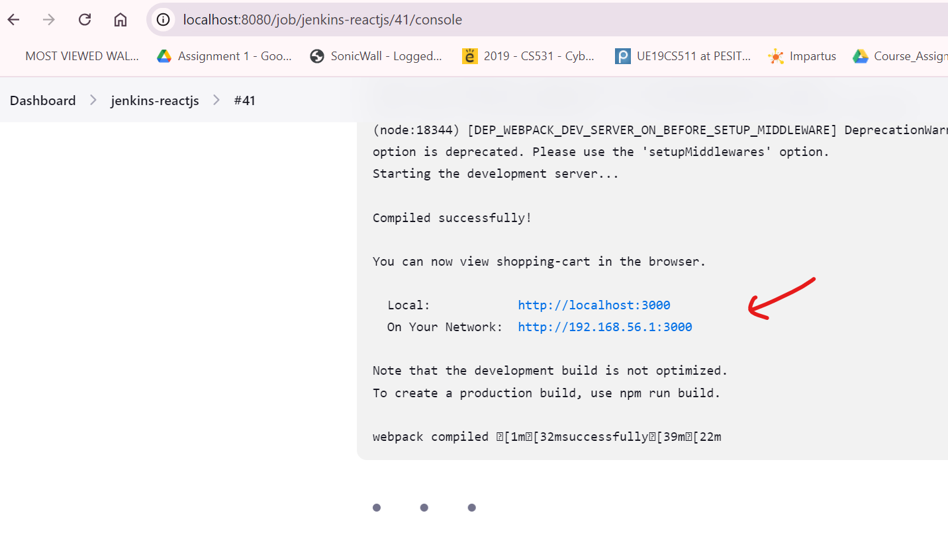

1. **Here is a manifestation of our app running.**

